TATEMS
~Help Guide~

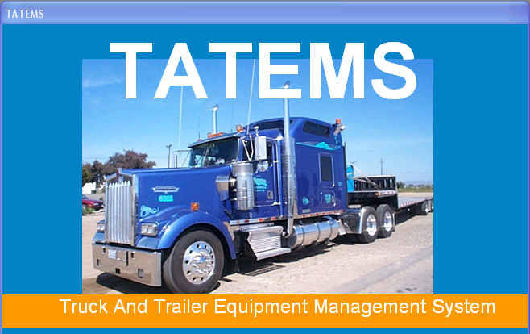

Copyright © 1998-2006 PCHelp, Ltd. All rights reserved.
www.tatems.com

Table Of Contents

Initial Setup 3
Adding a New Piece of Equipment 6
Equipment Summary Tab 7
Equipment Details Fields 7
Equipment Location 8
Current Odometer/Hours 8
Lubrication/Service 9
90-Day Inspection Dates 9
Driver History 9
Registration/Taxes Button 10
Insurance Button 10
Financials Button 11
Coolant Testing Button 11
Oil Analysis Button 11
Misc Details Button 12
90 Day Inspections Tab 12
Adding a new Inspection 12
Opening an existing Inspection 13
Lube/Service Tab 14
Needed Maintenance/Repairs Tab 15
Repairs Completed Tab 16
Parts for this Equipment Tab 17
Fuel Log Tab 18
Notes Tab 19
Filters Tab 20
Inspections/Permits Tab 20
Work Orders Tab 21
Tires/Wheels Tab 26
Toolbar Menus 27
Edit 27
Records 27
Reports 27
Forms 29
Forms/Customers 29
Forms/Dropdown List Maintenance 30
Forms/Parts Inventory 30
Forms/Personnel 31
Forms/Hazardous Waste Inspection Log 32
Forms/Reminders Popup 33
Equipment Search 38
Exit Program 38

Initial Setup

File→My Company Information:
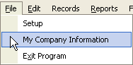

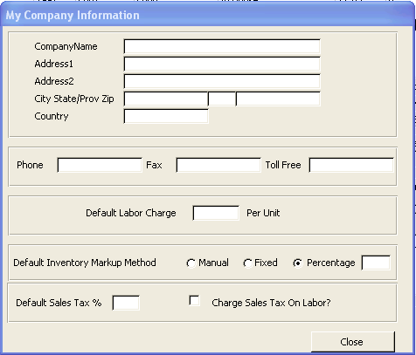
The information on this form is used to insert your company information into reports;
Company Name, Address, Phone, etc… is used to personalize various reports in TATEMS.
- The default labor charge – The information you enter here it will be the default amount displayed on labor for new Work Orders.
- Default inventory markup method – This section allows you to markup your parts.
  - If you choose manual, you’ll have to manually enter your markup amount on each part.
  - If you choose fixed, enter an amount to the right, then that amount (for example $10) will be added to the cost of the part.
  - If you choose percentage, enter an amount in the box to the right, then that percentage amount will be added to the cost of the part.
- Default Sales Tax – Enter an amount here to be used for Work Orders.
- Check the “charge sales tax on labor box” if your municipality requires you to charge your customer sales tax on labor.

File→Setup:
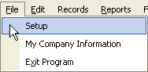

- Click on “Change Global Inspections Items list”

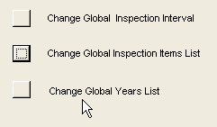

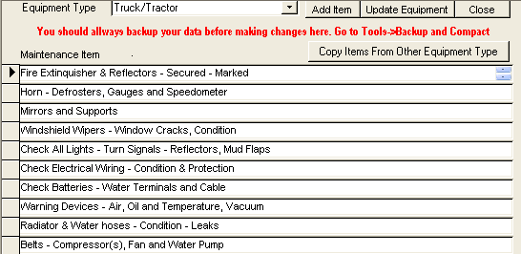

- Equipment Type - You can add equipment types on the fly by typing into the dropdown list for ex. Forklift, backhoe, delivery van, etc…) You should try to keep the equipment types to a minimum. The more equipment types you add, the more resource intensive it becomes to process the information.
- Maintenance Items - This list represents all the descriptions of equipment maintenance items that might be inspected. You can add to this list by scrolling to the bottom and adding in additional items. You can change items by highlighting and typing over. You can delete items by clicking the square to the left of the item and pressing the delete key.
- Copy Items From Another Equipment Type – Utilize this button to copy a list of maintenance items from an existing equipment type, to a new equipment type.

Change Global Inspection Interval

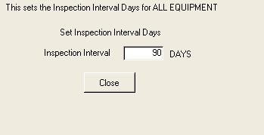

This number must be greater than 30 and less than 366. It affects the inspection tab and reminders associated with reminders. This changes Global for all equipment.

Change Global Year List

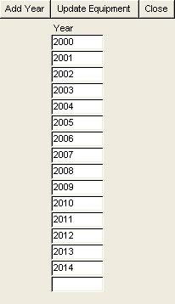
- This list of years is use to create inspections for each piece of equipment for the number of years seen. If you add additional years, be sure to click on the Update Equipment button before you close.

Adding a New Piece of Equipment

These steps will explain how to add a new piece of equipment. Each field is addressed individually. Grayed fields are not available for entering information. That field is populated from other sources. See the individual field titles for further information.
- Click on the Records menu at the top of screen and choose Add New Equipment each time to add a new piece of equipment. It’s going to ask you to enter a number that identifies that piece of equipment. (Enter a #) You’ll get the following messages:
Note: Make sure that you are using a new number. Using an existing number could cause problems with your records.
- “Please wait while a new record is created”. Click OK.
- “Equipment Number (the # you picked) added.” Click OK.
- “Since you’ve added a new piece of equipment, do you want to have the system to re-create the sort order?” Click yes if you want the sort order recreated.

Enter Description: For example: (1983 Ford F700 Water Truck)

Type: This is to enter the equipment type. For example: Truck/Tractor, Trailer, Fork Lift, etc. There is a drop down list and if your selection is not there highlight the box and type it into add it in on the fly.

Note: If you are going to add Equipment Types then you should add all your Equipment Types before you add more than a couple of pieces of equipment.
(See the “Change Global Inspection Items List” section under File-Setup)

Equipment Summary Tab
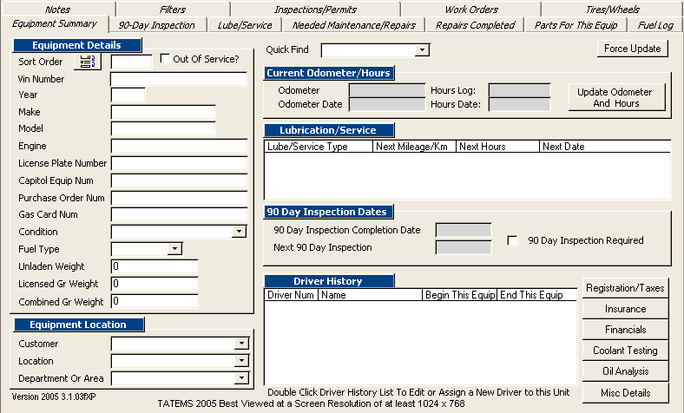

This shows all the info on any given piece of equipment provided info has been entered.
See “Adding a new piece of equipment”

Equipment Details Fields:
Enter Trucks/Trailers/Equipment to be tracked.
Fill in all pertinent info, not all fields need to be used. Check the “Out of Service” box if you do not want this piece of equipment to show up on your reminders.
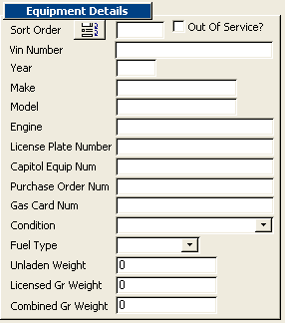

Equipment Location:
There are 3 different fields that you can use. You can add different options to each list by clicking on the box, and typing in what you want it to say and then hit tab, you will get a message “Not on the list, Do you want to add to list?” Click Yes.

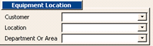

The customer field will show up on your Work orders. If you don’t service outside customers, then you can choose “in house” as your customer. The customer, location, Department or Area fields can be used to filter your searches in the equipment search section above.

Current Odometer/Hours:
Click on the Update Odometer and Hours button.

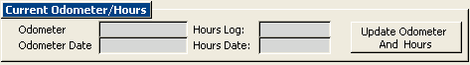

Update mileage or hours, depending on how you track that piece of equipment.
Click on Update & Close to complete the update.
It’s important to update your hours or mileage on a regular basis so that reminders that are based on mileage or hours will be properly triggered.
Note: If you make a mistake, you can click the “View All for This Equipment” button to find your mistake and delete it.

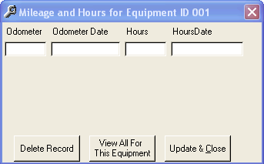

Lubrication/Service: This info will be auto-populated from information entered into the Lube/Service Tab.
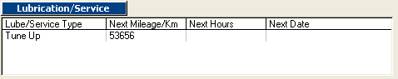

90-Day Inspection Dates
The 90-Day Inspection Date fields will be auto-populated from information entered in the 90-Day Inspection Tab.
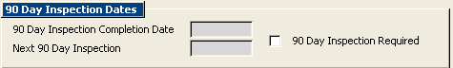

Driver History:
Double click in the white area of the Driver History List to edit or assign a new driver to this unit.
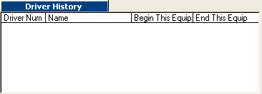
Double Click Here

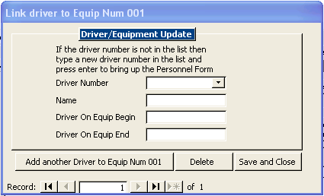

If you add a new driver number to the list when the personnel form pops up. Select the driver check box to make sure that it shows up in the driver/equipment update screen. This allows you to keep a running history of who was on the equipment and when. This can be useful, if you want to keep track of who’s using your equipment, especially if you notice a high number of repairs during a certain period.

Registration/Taxes Button
The dates and the intervals entered in the following screen are used to generate reminders for those items.
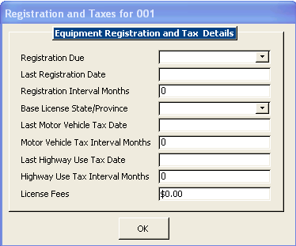

Insurance Button
The dates and the intervals entered in the following screen are used to generate reminders for those items.
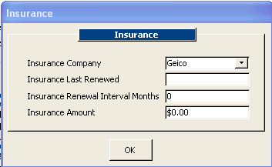

Financials Button
This is general information and does not generate any reminders.
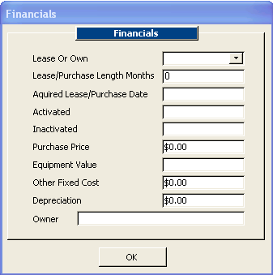

Coolant Testing Button
The Coolant Testing screen is used to keep track of Coolant Test results.
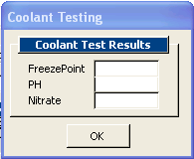

Oil Analysis Button
Enter when the Oil Analysis was completed and when you want it retested. No reminders are currently generated from this screen.
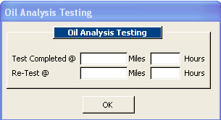

Misc Details Button
Informational only and will show up on the unit information report under reports→current equipments report
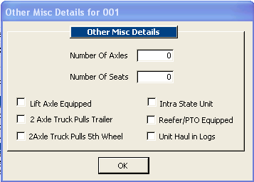

90 Day Inspections Tab

Adding a new Inspection
Click on Equipment Item# that you want to add an inspection for
- Click on the 90 Day Inspection tab
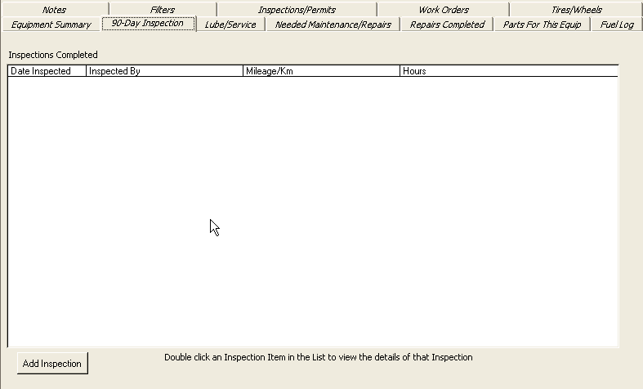

- Click on the Add Inspection Button

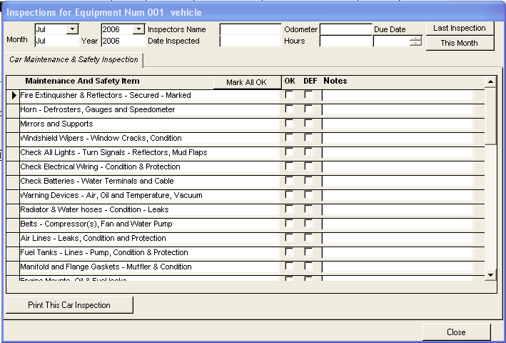

When this screen opens the inspection you are viewing will automatically default to the current month and year.
- Select the month and year that the inspection was performed.
- Enter the name of the person who inspected the vehicle.
- Enter the mileage or hours. (Mileage for vehicles and hours for equipment.)
- Enter the actual date inspected. (The date inspected must match the month and year selected) TATEMS will automatically calculate the date for the next inspection in the Due Date field. This date will appear on your reports.
- Click either the OK or DEF (defective) box placing a check mark next to each necessary inspection field to indicate result of inspection. Or leave blank if not applicable.
Note: If you check it as defective, then that item will be copied to the Needed Maintance Repair section.
- Enter any notes pertaining to a particular item.
- Click the print button to print out this inspection.

Clicking the Last Inspection button will provide information on the last inspection completed for this piece of equipment, if there was a previous inspection.

Clicking the “This Month” button will return you to the inspection for the current month.

Opening an existing Inspection:
If there has already been inspections preformed, they will display as a list in the 90 day inspection tab where it says inspections completed. Double click on any inspections listed to view the details for that inspection.

Lube/Service Tab
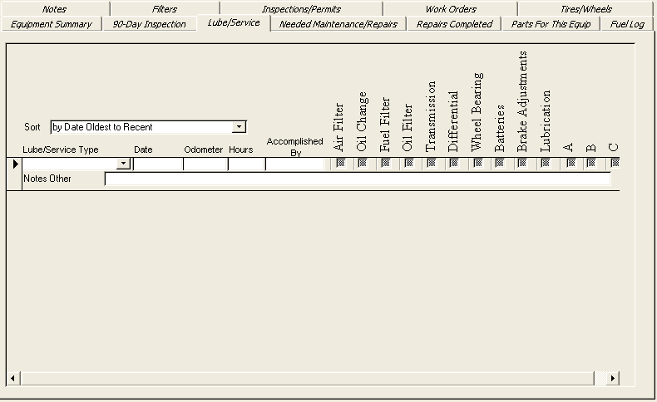
The lube/service tab is important to use in order to create reminders, even if you have a new piece of equipment you’ll need to enter something in here to generate a reminder for the next lube/service that needs to be done.

- Enter the Lube/Service Type – Use drop down list or type in your own description. You can create multiply service types for each piece of equipment. If the Lube/Service type you need is not in the list, you can type it in to add it to the list. When you add a new Lube/Service type to the list for example “12,000 mile service” and press the tab or enter key you will be prompted to add it to the list. A series of 3 prompts will display after you click ok – you will be asked for the mileage interval, the hour interval, and the day’s interval. If the Lube/Service type is based on mileage then when you see the prompt for hours and days you can click ok to bypass them.

- Enter the date of the lubrication.

- Enter odometer or hours – Odometer reading for vehicles/hours for equipment.

- Enter the name of the person who performed the lubrication.

- Click on a box beneath the item, placing a check mark in it to indicate which item was completed. (You may also tab through the box fields and use the Space Bar to place the check mark.)

- Boxes labeled A, B & C cannot be changed and most companies have an industry standard or custom list of maintenance items that correspond to a; A schedule, B schedule or C schedule.

- The Sort function allows you to sort your entries.

Displaying on Reports:
The Lube/Services will be displayed on the following reports:
- Reports → All Equipment Reports → All Equipment due next 30 days
- Reports → All Equipment Reports → All Equipment last/next maintenance
- Reports → Current Equipment Reports → Lube & Inspection Report
- Reports → More Reports → Report Type → Lube/Service
- The report printed from the Reminders popup screen

Needed Maintenance/Repairs Tab
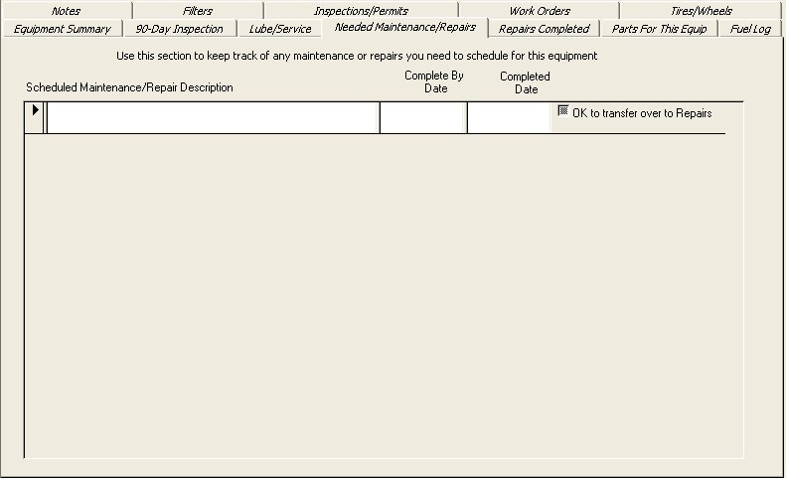

The Needed Maintenance/Repair section allows you to keep track of any maintenance or repairs you need to schedule for this equipment. Some users use the Needed Maintenance/Repair tab, the Repairs Completed tab and the Parts for this Equipment tab instead of Work Orders. Some users like to use both Work Orders and these tabs, the choice is yours.

- Adding a new Maintenance/Repair Item: Type in the description and the completed by date. The maximum number of characters including spaces is 200.

- Completed Date: Once you have entered a completed date, the item will no longer display on the Needed Maintenance/Repairs report.

Displaying on reports:
The Needed Maintenance/Repairs Reports will be displayed on the following reports:
- Reports → All Equipment Reports → Needed Maintenance/Repairs
- Reports → More Reports → Report Type → Needed Maintenance/Repairs.
- Reports → All Equipment Due next 30 days reports under

- Transferring to Repairs Tab: Click on the “OK to Transfer to Repairs” tab when you want to transfer the information over to the Repairs Completed section.

- Automatically adding from 90 Day Inspection’s: When you click an item as defective while doing a 90 day inspection, that item will automatically transfer to the needed Maintenance/Repairs tab

Repairs Completed Tab
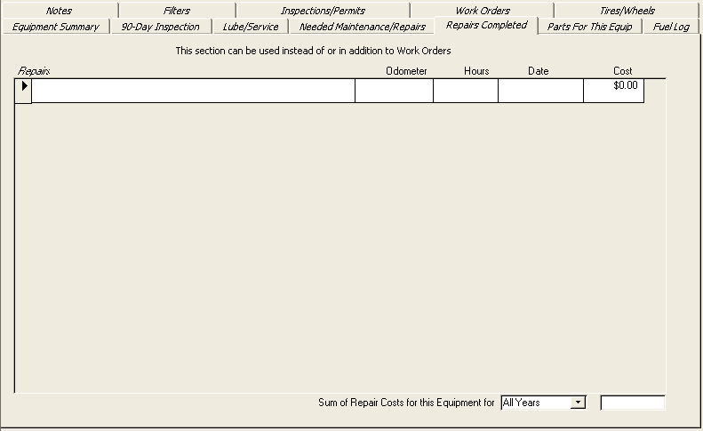

The Repairs/Completed section allows you to keep track of any repairs completed on this equipment. Some users use the Repairs Completed tab, the Needed Maintenance/Repairs tab and the Parts for This Equipment tab instead of Work Orders. Some users like to use both Work Orders and these tabs, the choice is yours.
- Adding a new Completed Repair Item: Type in the description and the completed by date. The maximum number of characters including spaces is 200.
- Odometer: Enter the odometer reading at the time of the repair
- Hours: Enter the hours on the equipment at the time of the repair
- Date: Enter the date when the repair was completed
- Cost: Enter the total cost of this repair
- Sum of Repair Costs for this Equipment: (located in bottom right corner) Select a year (either all years or a single year) to display a total repair cost for this piece of equipment.

Displaying on reports:
The Repairs Reports will be displayed on the following reports:
- Reports → Current Equipment Reports → Repairs Report
- Reports → More Reports → Report Type → Repairs Completed.

Parts for this Equipment Tab
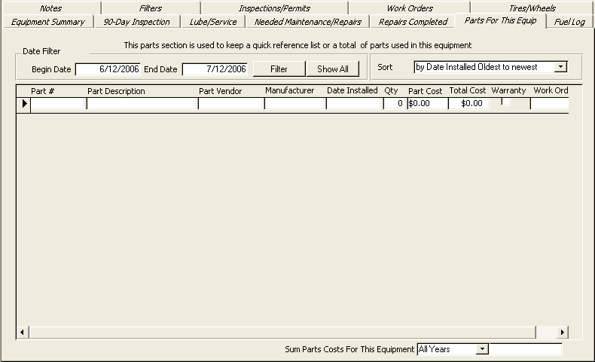
The Parts for this Equipment section allows you to keep track of any parts used on this equipment. When this section was first created, it was used primary for a quick reference to commonly used parts. However it can be used to track all parts used for this equipment. You can transfer a copy of the parts used in a Work Order into this section.
This section will not pull parts from your parts inventory. Some users use the Parts for this Equipment tab, the Repairs Completed tab and the Needed Maintenance/Repairs tab instead of Work Orders. Some users like to use both Work Orders and these tabs, the choice is yours.
- Part #: Enter text or numbers up to 50 characters
- Part Description: Enter text or numbers up to 150 characters
- Part Vendor: Enter text or numbers up to 50 characters
- Manufacture: Enter text or numbers up to 50 characters
- Date Installed: The date the part was installed on this equipment
- Quantity: Numeric value representing how many were used
- Part Cost: Cost of part
- Total Cost: This is automatically generated
- Warranty: Check if it applies
- Work Order ID: This field will be filled in automatically if you copy the part from a Work Order, you can double click in the Work Order ID field to display the Work Order that this part was used on
- Date Filter: When the program first opens the begin & end date will default to the past 30 days. To change the begin/end dates, click on the filter button to show parts used in a different time frame. You can use the show all button to show all time frames.
- Sort: There is a number of sort criteria to pick from

Displaying on reports:
The Parts for this Equipment Reports will be displayed on the following reports:
- Reports → Current Equipment Reports → Parts Report
- Reports → More Reports → Report Type → Parts Installed

Fuel Log Tab
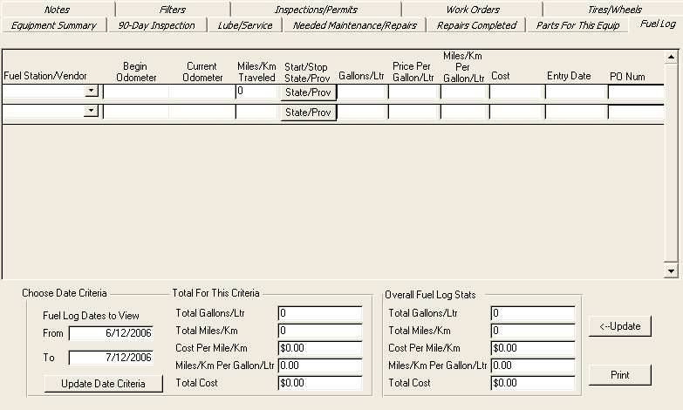

The fuel log allows you to keep track of various items relating to fuel for each piece of equipment

- Fuel Station/Vendor: Select an existing Fuel Station/Vendor or type a new one in the field to add to the list. Enter text or numbers up to 50 characters
- Begin Odometer : Enter the odometer reading at prior fill up
- Current Odometer : Enter the odometer reading at this fill up
- Miles/Km Traveled : Automatically generated
- Start/Stop - State/Prov : Click on the State/Provence button
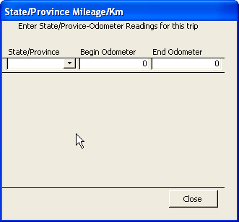
Select a State/Province from the list or type a new one in the field to add to the list.
Enter Beginning Odometer and Ending Odometer readings.
- Gallons/Ltr: Enter # of Gallons/Liters used.
- Price per Gallon/Ltr: Enter Price per Gallon/Ltr.
- Miles/Km per Gallon/Ltr: This is automatically generated.
- Cost: Automatically generated. You can override this amount
- Entry Date : Automatically generated when you select a fuel station vendor
- PO Num : Numbers or letters, Maximum of 50 characters
- Choose Date Criteria: When you first open TATEMS, the “From Date” criteria defaults to 30 days prior to the current date. The “To Date” defaults to the current date. Change these two dates to view fuel log entries and totals for any time period.
- After you have altered the dates click on the Update Criteria button to update results
- Overall Fuel Stats : Will display all fuel stats for this piece of equipment regardless of date criteria chosen
- Update Button: This will force an update of all totals.
- Print Button: Will print out a report of fuel log information for this piece of equipment based upon the date criteria chosen.

Notes Tab
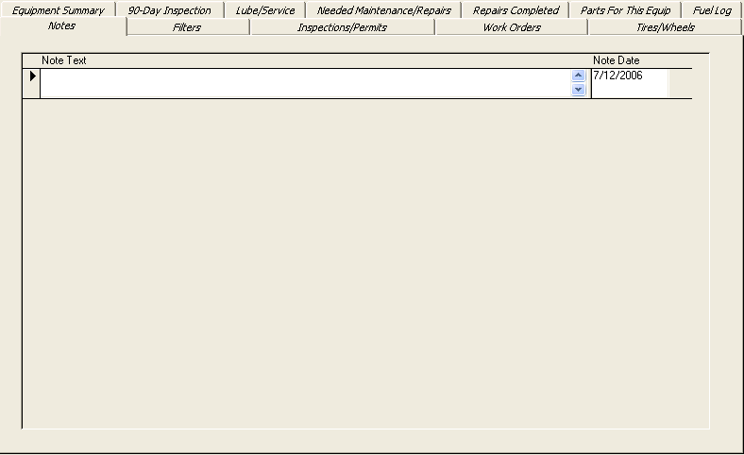
Here you can enter any kind of note regarding the piece of equipment.
- Enter text or numbers up to 255 characters.

Filters Tab
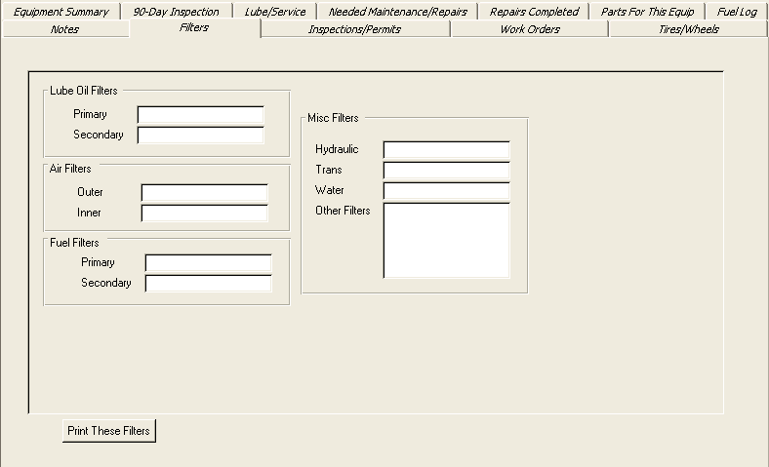
Additional information regarding filters can be entered here.
- Lube Oil Filters: Enter text or numbers up to 25 characters.
- Air Filters Enter: Enter text or numbers up to 25 characters.
- Fuel Filters Enter: Enter text or numbers up to 25 characters.
- Other Filters under Misc Filters: Enter text or numbers up to 75 characters.
- Print These Filters Button: Click to print filters for this piece of equipment only.

Inspections/Permits Tab
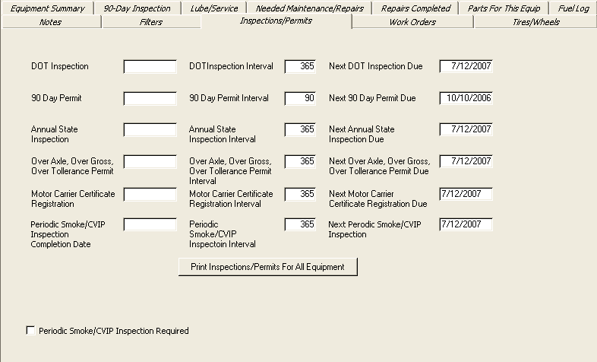
- The first column is a date field. Enter the date of the last inspection/permit.
- The second column – enter the number of days between inspections.
- The third column will show you the date when the next inspection/permit is due.
- Periodic Smoke/CVIP Inspection Require: Check if you want to have them appear on reminders.
- Print Inspections/Permits For All Equipment Button: For all inspections/permits for all equipment

Work Orders Tab
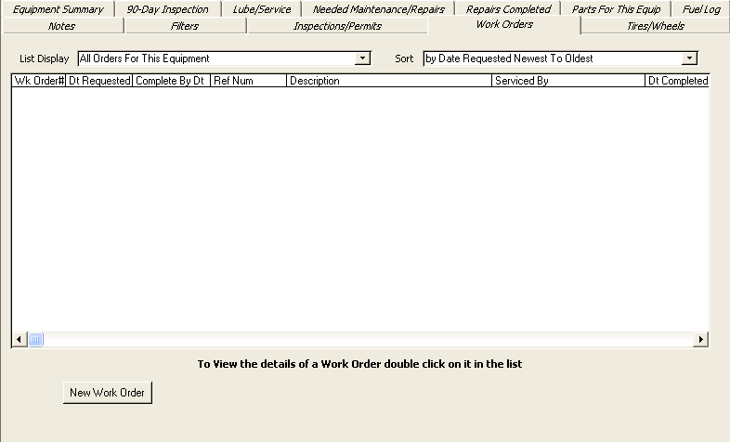
Click on New Work Order Button to add a new Work Order.

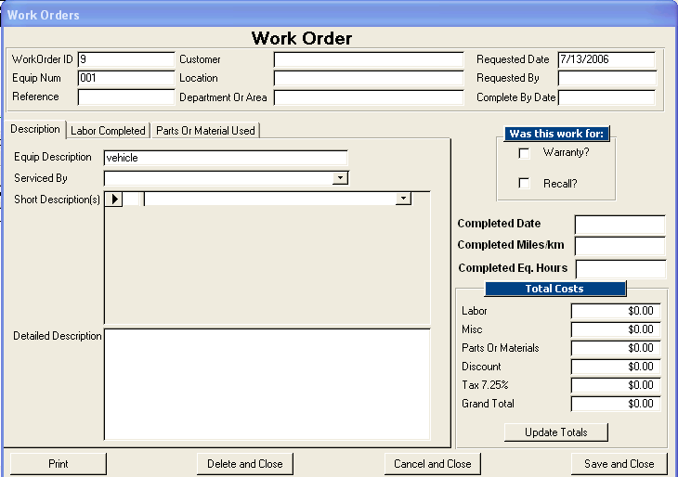

- Work Order ID: When you open a new work order the Work Order ID # is auto generated. It will increase by 1 every time you open a new work order even if you deleted the one previous.
- Equipment Num: Cannot be changed, this is pulled from the current equipment you are viewing.
- The Reference field: is for you to use as you see fit. Maybe you would like to reference this work order to something else. Maximum of text or numbers 30 characters
- Customer, Location & Dept: This information is from information entered on the Equipment Summary Screen for this piece of equipment.
- Requested Date: Automatically generated when you start a new Work Order and defaults to the current date. This can be overridden. This can be used in some of the Work Order reporting criteria.
- Requested By: Enter the name of the person who is requesting the Work Order. 30 characters max.
- Complete By Date: Enter the date the Work Order should be done by. The date entered will be use to show all Work Orders Pending in the All Equipment due in 30 days report.
- Serviced By Field: Enter the name of the company or shop that serviced the piece of equipment.
- Warranty / Recall: Check if it applies
- Completed Date: Enter the date the Word Order is completed. This date is used in reporting criteria
- Completed Miles/km: Enter the Odometer reading on the equipment at the completion of this Work Order.
- Completed Eq. (equipment) Hours: Enter the hours metered on the equipment at the completion of the Work Order.
- Total Cost:
  - Labor: Labor costs are pulled from the Labor Completed tab
  - Misc: Misc costs can be entered at will.
  - Parts or Materials: Costs are pulled from the Parts or Materials Used tab.
  - Discount: Enter amount that you would like to discount this order.
  - Tax Percentage: Is calculated based upon what you entered in the “My Company Information” section. This can be overridden.
  - Grand Total: Cost is automatically calculated when you click on the Update Total Button.
  - Print Button: Click the print button to preview and print the Work Order either as a pending Work Order or a completed Work Order, depending on whether the completed date has been filled in or not.
  - Delete and Close Button: Click this button to delete the entire Work Order and close the screen.
  - Cancel and Close: Will close the Work Order without saving changes.
  - Save and Close: Will save changes and close screen.

W/O Description Tab:
  - Equip Description: Cannot be changed and is pulled from the Equipment Information.
  - Serviced By: Enter either in house or outside vendor info. Max 40 characters
  - Short Description: Enter a short description. Max 80 characters. As you add multiple short descriptions the numeric field will automatically count up. The dropdown list is automatically added to each time you add new short description. Keep your short descriptions as generic as possible to avoid creating a lengthy list.
  - Detail Description: Larger description. Max 64,000 characters.

W/O Labor Completed Tab
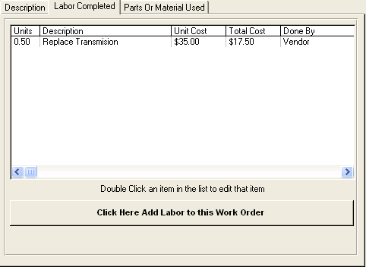
The list will be populated with all of your labor items.
- To add a labor item: Click the button
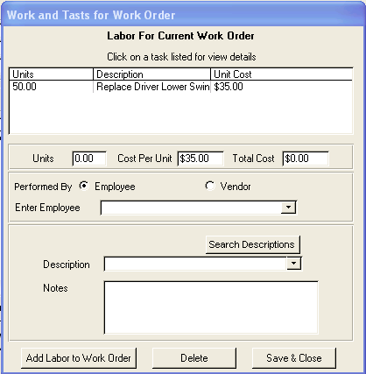
When the labor for Current Work Displays enter the pertinent information pertaining to each labor item
- Units: This can be put in as whole numbers or decimals and is a required field. If you do not enter units the labor will not be entered to the Work Order.
- Cost per Unit: This amount is automatically pulled from the “My Company Info” section under file menu and can be overridden.
- Total Cost: Is automatically calculated.
- Performed By:
  - Employee: Check here if Employee performed. A drop down will display a list of employees to pick from, from your personnel records under Forms→Personnel. You can add employees to the list if not already there. When adding employees to the list there will be a series of 3 prompts. First Name, Last Name, Assigned Employee Number provided by your company.
  - Vendor: Check if Vendor performed
- Search Description: Required field. Enter a description of the labor. Maximum 50 characters. If you do not enter a description the labor will not be saved to the Work Order.
- Search Descriptions Button: Use the search description button to popup a search screen to help you find the description you are looking for.
- Notes: Enter any notes pertaining to this labor task. Maximum 255 characters.
- Add Labor to Work Order Button: Click this button to add this labor entry to the Work Order and to continue adding labor entries without closing this screen.
- Delete Button: Used to delete the currently viewed labor entry.
- Save & Close Button: Save item and close the screen.

W/O Parts or Material Used Tab
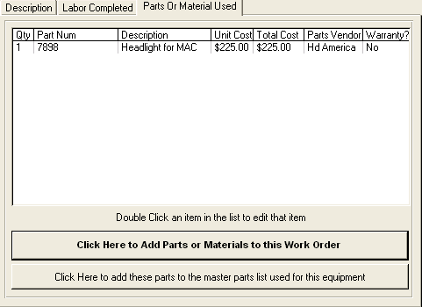
- Click the “Click Here to add Parts or Materials to this Work Order” Button to open a pop up screen that allows you to add Parts or Material s to this Work Order.

- Click the “Click Here to add these parts to the master parts list used for this equipment” button. If you want to add the parts used in this Work Order to a running list of parts used on this piece of equipment. They will be copied over to the Parts for this Equipment section.

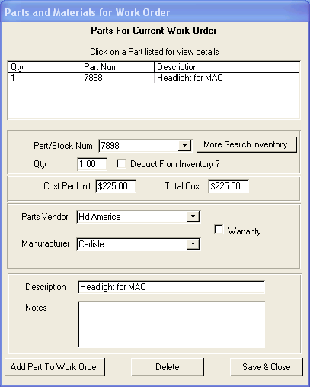
This is the screen that pops up to add Parts or Materials to the Work Order.

- Parts/Stock Num: Required field. Type in a parts stock number or pick one from the drop down list. You can add a new number by typing it in. Follow the prompts to add the parts to the list. Max. 50 characters, text or numbers.
- More Search Inventory Button: Click here to bring up a list of part #s
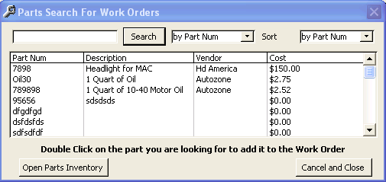
- Qty: Required field. Whole numbers or decimals.
- Deduct From Inventory: Check if yes.
- Cost Per Unit: This is pulled from the Parts Inventory list and can be overridden.
- Total Cost: Automatically calculated.
- Parts Vendor: Automatically auto-populated from Parts Inventory and can be overridden. Maximum 25 characters, text or numbers.
- Parts Manufacturer: Automatically auto-populated from Parts Inventory and can be overridden. Maximum 30 characters, text or numbers.
- Warranty: Check if it applies.
- Description: Maximum 50 characters
- Notes: Maximum 255 characters.
- Add Part to Work Order Button: Click this button to add this Part entry to the Work Order and to continue adding Part Entries without closing this screen
- Delete Button: Used to delete the currently viewed Part entry.
- Save & Close Button: Save entry and close the screen.

Displaying on reports:
Reports → More Reports → Reports Types → Work Orders
There are 9 reports to choose from in this section.

Tires/Wheels Tab
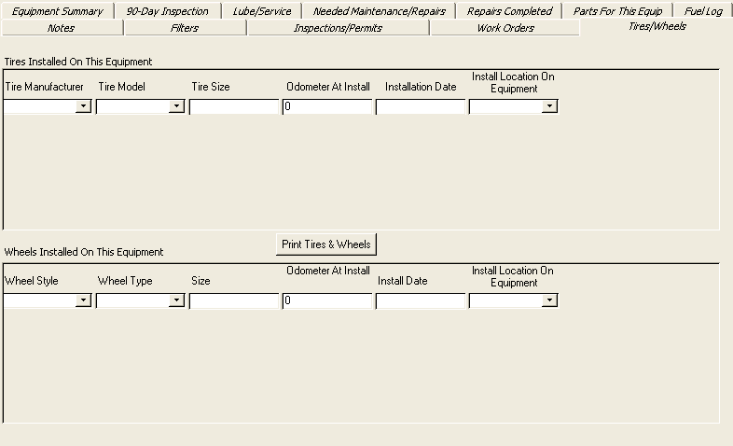
Enter information regarding Tires & Wheel
- Tires Installed On This Equipment:
  - Tire Manufacturer: Select from the drop down list or enter a new one. Max 25 characters
  - Tire Model: Select from the drop down list or enter a new one. Max 30 characters
  - Tire Size: Key in the tire size. Max 20 characters.
  - Odometer At Install: Odometer reading at time of installation.
  - Installation Date: Date of installation.
  - Install Location On Equipment: Enter where the tire was installed on equipment. For example “left front”. Max 20 characters.

- Wheels Installed On This Equipment
  - Wheel Style: example “10 hole” Max 30 characters.
  - Wheel Type: example “Bud, Dayton or Pilot. Max 30 characters.
  - Size: example “22.5” Max 20 characters
  - Odometer At Install: Odometer reading at time of installation.
  - Install Date: Date of installation.
  - Install Location On Equipment: Enter where the wheel was installed on the equipment. For example “left front”. Max 20 characters.

- Print Tires & Wheels Button: Click the Print Tires and Wheels button to print a list of all Tires and Wheels installed on this piece of equipment.

Toolbar Menus

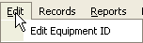
Edit

Edit Equipment ID: The equipment ID field on the main form is normally locked and cannot be edited. You can use this menu item to edit the Equipment # field.

Records
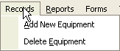

Add New Equipment: Use this menu item to add a new piece of equipment to the database.
Delete Equipment: Use this menu item to delete the currently displayed piece of equipment from the database.

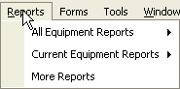
Reports

To Preview the report click on the icon

To Print the report click on the icon

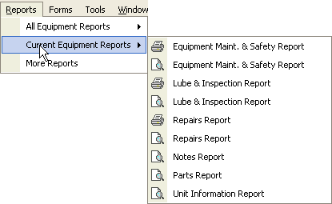
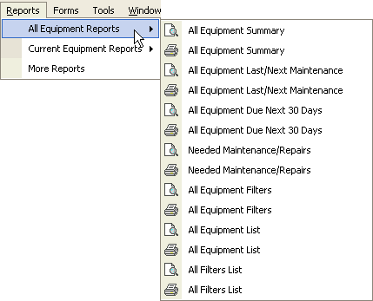

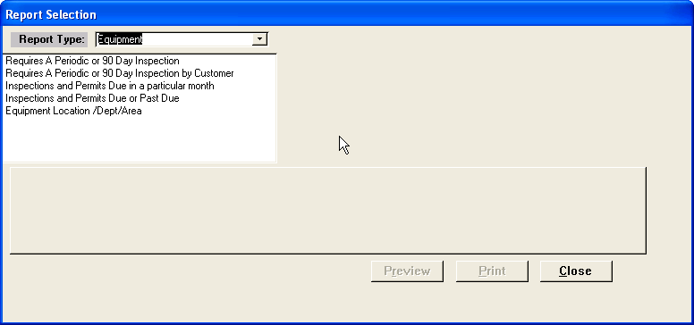
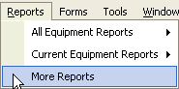

Additional Reports
These reports will change
To fit the screen you are on.

- Before you can generate a report. You need to make a selection from the list of available reports after you choose a Report Type.

Forms
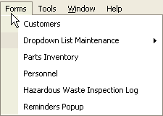

Forms/Customers
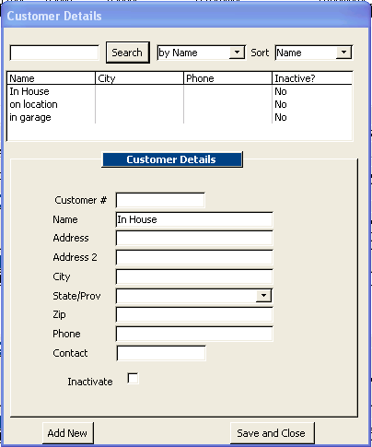
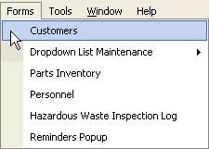

- Add a new customer: To add a new customer, fill in the information. Click add new or save & close
- Search for a customer: Use to find a customer.
- Inactivate a customer: When you click to inactivate a customer, the customer no longer shows up in the dropdown list on the Equipment Summary screen. However, if a customer is still linked to a piece of equipment, then that customer will still display on the Equipment Summary page until a different customer is selected for that equipment.

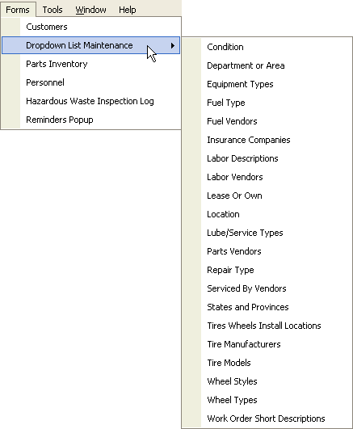
Forms/Dropdown List Maintenance

- Utilize each of the Dropdown List Maintenance items to pop up a screen that will allow you to edit various dropdown lists within the program

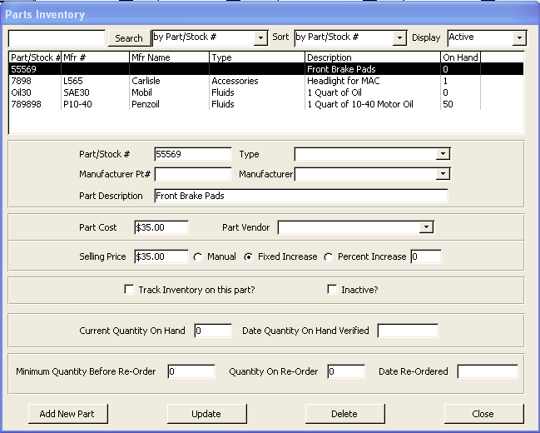
Forms/Parts Inventory
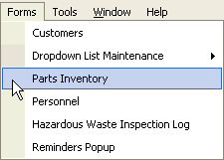

- Enter: Parts/Stock #, Type, Manufacturer Pt#, Manufacture, Part Description,
- Part Cost: Actual Cost of part.
- Part Vendor: Select a Vendor.
- Selling Price: Will automatically default if you choose a fixed or percent increase in the “My Company Information” section. This can be overridden for each individual part.
- Track Inventory on this Part: Check this box if you want to be reminded when inventory gets low on this part.
- Inactive: Check this box when you want to make the part inactive, but not deleted from system.
- Current Quantity on Hand: The physical count of # of parts on hand.
- Date Quantity on Hand Verified: Date inventoried.
- Minimum Quantity before Re-Order: Enter the minimum amount you want to have on hand before needing to re-order. When you hit that number a reminder will pop-up.
- Quantity on Re-Order: How many you re-ordered.
- Date Re-Order: Enter the date you re-ordered.
- Delete Button: If you delete a part from the Parts Inventory that has already been added to a Work Order, then that part will be deleted from the Work Order. This will skew your Work Order totals.

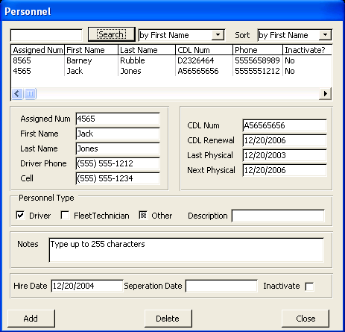
Forms/Personnel
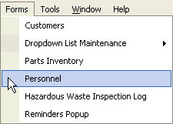

- CDL Renewal: Those dates are used to generate reminders
- Next Physical: Those dates are used to generate reminders
- Personnel Type:
  - Driver: For an employee to show up as an available driver, the driver box must be checked.
  - Fleet Technician: Must be checked in order to display on the employee list when add labor to a Work Order.
  - Deleting: If you delete an employee that was linked to a piece of equipment or Work Order, then the history of that employee will be deleted as well.

Forms/Hazardous Waste Inspection Log
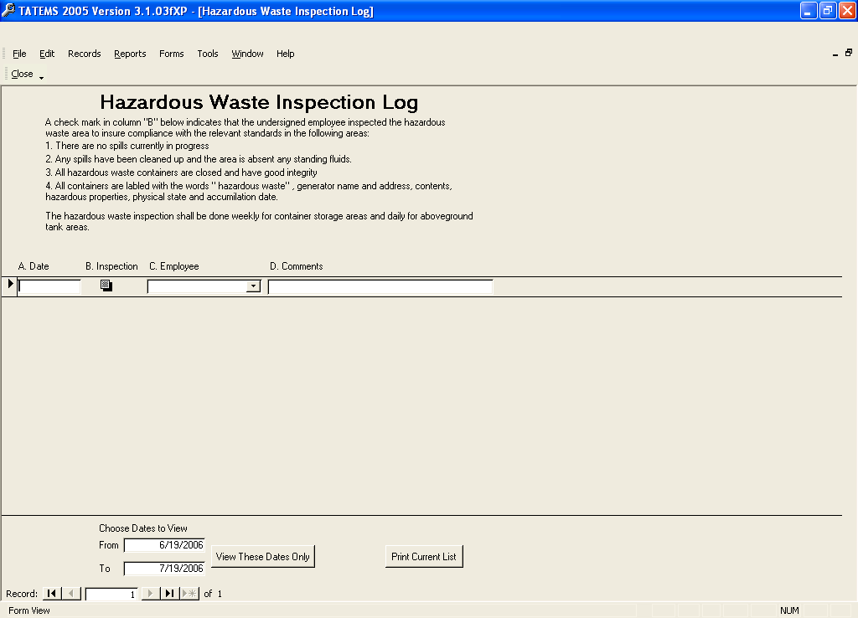
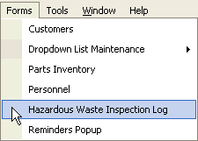

- Simply follow the instructions on the form.

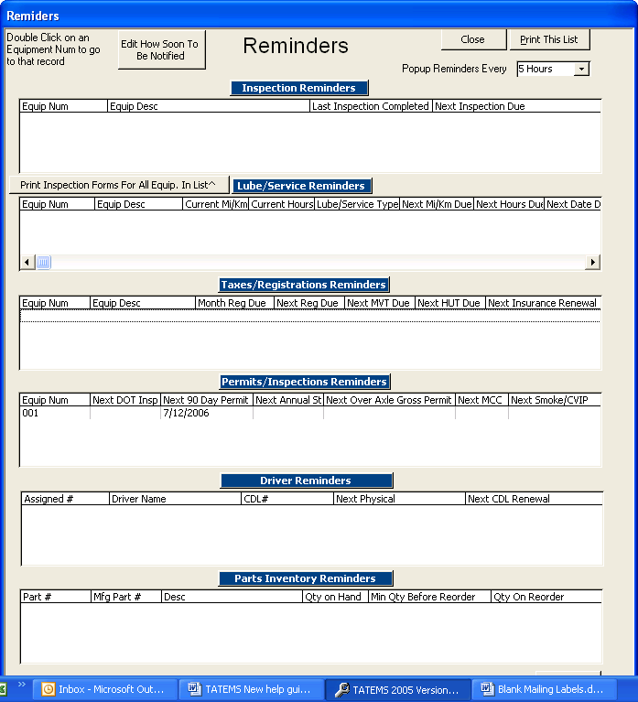
Forms/Reminders Popup
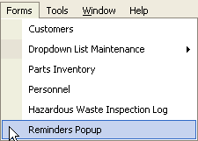

- Edit How Soon To Be Notified Button: Click this button and a window will pop-up allowing you to enter miles, hours & days in advance that you would like to be notified before an item is due.
- Pop-up Reminders Every: Select 1 to 8 hours from the dropdown list. This will set the time interval to check for reminders while TATEMS is open.
- Print Inspection forms for All Equipment in List ^ : Click this button to print out a separate blank inspection form for each item in the inspections reminder section. The blank list can be passed out to the person doing the physical inspection.
- Print This List Button: Click this button to generate a printout of every item displayed on the reminder screen.

Tools
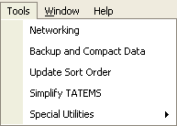

Tools/Networking
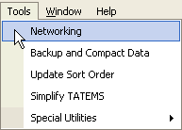
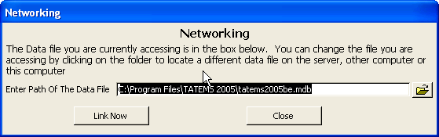

Tools/Networking
The program has to be installed on each computer that will need to run it. If you are using one machine as a server that will not be running the program you will NOT need to install the
program on the Server machine. The Server machine only needs the tatems2005be.mdb file. Please note that a license is required for each machine that runs the program. There is a discounted, multiple license offer on the purchase page at http://www.tatems.com .

More networking instructions:
The file that holds the actual DATA that you have entered is called “tatems2005be.mdb”
Make a backup copy of this file. You will use it on the computer you want to act as the server. So go ahead and copy it to the Server Machine.

In order to network TATEMS you will need to designate one of the computers as a server that will store the data.

When you want to link the TATEMS software running on a workstation to the DATA FILE
on the server just click on Tools Networking.

Then click on the open folder icon to locate the DATA FILE on the SERVER.

The dialog looks like a file->open dialog for most other programs.

You will need to navigate to the tatemsbe2005.mdb file that is on the computer acting as a server. The program seems to run best if you map a drive letter that points to the server
computer.

So you should navigate to something like
F:\Server\Program Files\TATEMS2005\tatems2005be.mdb

You should be able to just double-click on the file and the path will display in the box.

Then click on Link Now to link this copy of TATEMS to the DATA FILE.

To Backup TATEMS Data:
In order to save and backup your data you need to make a backup copy of a file called
tatems2005be.mdb this is the file that contains all the data you enter into the program.
This file is in the folder C:\Program Files\TATEMS 2005\

The program needs to be closed whenever you backup or restore this file.

If you ever have to reinstall the program, you will need to restore this file back into it's folder after reinstalling in order to work with the backed up data.

A couple of additional things need to be addressed here.
There is a Backup and Compact feature in TATEMS under Tools->Backup and Compact.

Tools/Backup & Compact Data
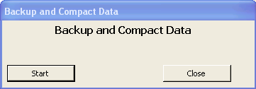
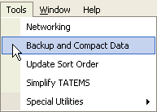

The Backup and Compact feature only allows you to backup the data to the same folder where the data file is housed. So if the data file is in C:\Program Files\TATEMS 2005\ then the backup file will be created in that folder.

The backup file will be Date/Time stamped within the actual file name. It will look something like this. tatems2005be7-19-2006-09-12.mdb
The 7-19-2006 is the date part and the 09-12 is the time part in 24 hour time (9:12AM).

This can be useful if you want to go back to a "point in time" backup to see where some mistake was made or something went wrong.

These "point in time" backups and any backups for that matter should be moved off the hard drive to a CR-R, a Zip drive, USB drive or memory card for safe keeping.

The "point in time" backups should also be moved off your hard drive because they can quickly start taking up space, especially if you do them on a daily basis.

You can always link to a point in time backup by using the Networking Tool in TATEMS. Under: Tools->Networking. This will allow you to see what's in a file without having to rename it. Regardless of which approach you use to backup your data, you should do it on a daily basis.

Tools/Update Sort Order
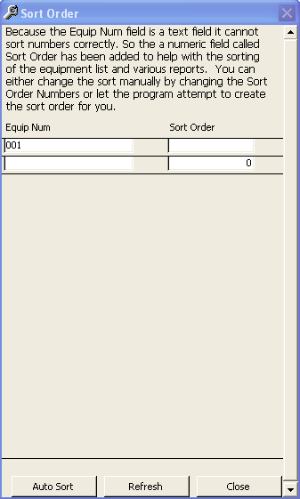
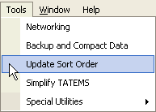

The Sort Order screen is used to maintain the sort order of your equipment.
Because the Equipment Number field allows you to use letters and numbers it is a text field and the sort order can become skewed and out of numerical order.

So a numerical field called “Sort Order” was added to each record to help overcome this problem.

There are two ways that you can update the sort order field:
- You can use the Auto Sort button seen at the bottom of the Sort Order screen. When you use the Auto Sort button, the system will attempt to create the best sort order based on the characters in the Equip Num field. If you only use numbers in the Equip Num field, then the Auto Sort will be quite accurate. If you use letters and numbers it may not be as accurate. So you may need to adjust the numeric values in the sort order column.
- You can also create your own sort order manually by assigning a numeric value in the sort order field to each equipment number.

Whenever you add a new piece of equipment you will be asked if you want to recreate the sort order. If you choose yes, then the program will do the same thing as clicking the Auto Sort button.

Tools/Simplify TATEMS
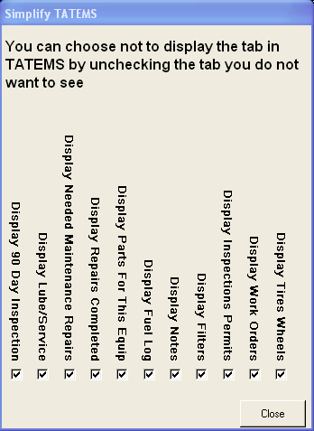
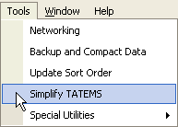

Use this form to remove Tabs from the TATEMS interface. When you un-check an item its corresponding tab will stop displaying on TATEMS.

This can be useful if you don't use certain features in TATEMS or if you have certain people using TATEMS that don't need those features.

Tools/Special Utilities
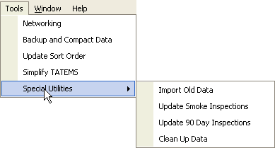

Import Old Data
The import Old data utility is used only to import data from a pre-non TATEMS 2005 version into a TATEMS 2005.
Don't use this utility to try to import data from a TATEMS 2005 version to a TATEMS 2005 version. Instead, just link to the data using the networking tool, or simply copy the data file to TATEMS directory

Update Smoke Inspections
The update smoke inspections utility is obsolete and was used to update smoke inspections that did not get properly updated while using a previous import utility.

Update 90 Day Inspections
The Update 90 Day Inspections utility is obsolete and was used to Update 90 Day Inspections that did not get properly updated while using a previous import utility.

Clean Up Data
The clean up data utility can be used from time to time to remove un-needed inspections that are no longer used by the system.

Equipment Search

- Enter an equipment ID number to view the records for a particular piece of equipment in the Equipment Search field.

Or

- Use the drop down arrow to search by: Description, Make, Model, Year, License Plate # Cap Equip # or PO Num

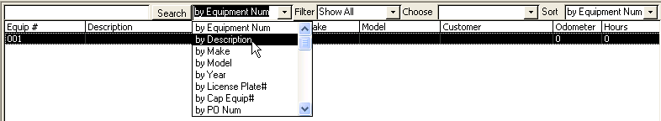

You can also use the Filter to filter the search list by Customer, Location or Department/Area. After you choose one of those filter items then the Choose field next to it will populate with all or your Customers or Locations or Department/Areas. Then your search will display only those pieces of equipment that fit that filter criteria.

When entering text to search for, you can enter partial text and the search will search for things that fit that partial match. For example, if you want to find all Chevys and Chryslers you could enter the letter “C” and choose Search By Make.

Exit Program
- Click on File. Click on Exit Program to quit the program.
- You may also click on the X in the top right corner to quite the program.

Copyright © 1998-2006 PCHelp, Ltd. All rights reserved.
www.tatems.com

